Memeber 1: Sharvayu Zade - 230700521135

Member 2: Shreya Bansal - 23070521144  
  
Practical 07 Activity

1. To-Do List With a Twist (Emoji Mode)

● What to build:

A basic to-do list, but every task must have an emoji selected from a dropdown.

● DOM Skills:

getElementById to get input and dropdown values.

createElement to create new list items.

appendChild to display the task with emoji.

querySelector to select tasks for edit/remove.

Extra fun challenge:

● Add a “Random Emoji” button that automatically selects a random emoji from a predefined array. 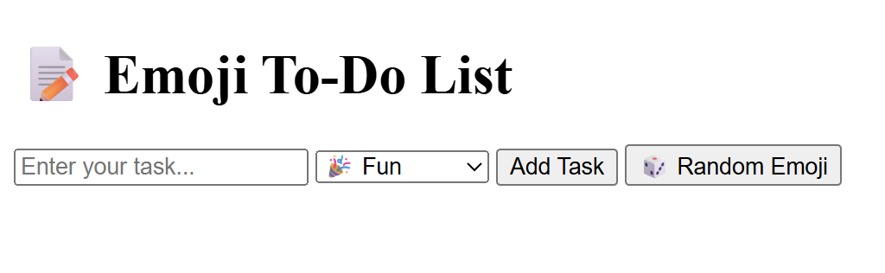

2. Color Palette Game

● What to build:

Generate 5 random colored boxes when the user clicks a button.

● Gameplay twist:

The system displays a target color code (e.g., #FF5733).

The student must click the box with the correct color.

When clicked, highlight it as “Correct” or “Try Again”.

● DOM Skills:

Create color boxes using createElement.

Use appendChild to add to the DOM.

Use querySelector to track clicks.

3. Build Your Own Quiz

● What to build:

A multiple-choice quiz where questions are generated dynamically from an array.

● Steps:

Store questions and answers in a JSON array.

Dynamically create question <div>s using createElement.

Allow user to select and submit answers.

Show score dynamically.

**●** Extra challenge: Add a timer using setInterval.

4. Random Joke or Quote Generator

● What to build:

A “Get Joke” button that displays a random joke or motivational quote each time it’s clicked.

● DOM Skills:

querySelector for selecting the joke area.

createElement to create <p> tags.

appendChild to insert them dynamically.

● Extra challenge:

Add a “Like” button to each joke and count total likes.

5. Student Scoreboard

● What to build:

A mini scoreboard to add and update students’ scores.

Steps:

Enter student name and score in input fields.

Display them in a table using createElement and appendChild. Allow updates when you click on a score (inline edit).

Remove a student by clicking a delete button.

● DOM Skills: Perfect for practicing DOM traversal and element manipulation.

6. DOM Treasure Hunt

● How it works:

Hide 5 <div> elements with treasure emojis randomly on the page. The student must find and click them using only querySelector or getElementById.

Each correct click changes the emoji to a treasure chest and increases the score.

● Extra challenge: Add a timer countdown to make it exciting.

7. Digital Dice Roller

● What to build:

A page with a “Roll Dice” button that displays:

A dice face (emoji or number 1-6).

A running total of all rolls.

● DOM Skills:

createElement for dice.

appendChild for results history.

querySelector for total updates.

Fun extension:

● Create a two-player version and display who wins.

8. Simple Meme Maker

● What to build:

A user uploads an image and types text for the top and bottom.

● DOM Manipulation:

createElement('img') for uploaded image.

appendChild to place text on the image.

querySelector to update text dynamically.